Qlik Analysis of Road Safety and Accident Patterns in India

# Introduction

Road safety is a critical concern worldwide, and India is no exception. Despite advancements in transportation technology, the country continues to grapple with a high incidence of road accidents. These accidents result in significant loss of life and injuries, with far-reaching social and economic impacts. Addressing this issue requires a comprehensive, data-driven approach to understand the underlying factors and implement effective safety measures.

This project aims to utilize Qlik Sense, a powerful data analytics platform, to analyze road safety and accident patterns in India. By leveraging various data sources, including traffic data, accident reports, weather conditions, road infrastructure details, and demographic information, we seek to identify trends, hotspots, and factors contributing to road accidents. The insights generated from this analysis will be instrumental in helping stakeholders, such as government authorities, transportation agencies, and road safety organizations, make informed decisions to improve road safety measures, reduce accidents, and save lives.

The project will focus on three primary scenarios:

1. **Hotspot Identification**: Using Qlik's analytics capabilities to pinpoint regions or specific roads with a high frequency of accidents, correlating accident data with factors like traffic volume, road conditions, and time of day.
2. **Trend Analysis**: Performing trend analysis on historical accident data to identify patterns and recurring factors, such as types of accidents, seasonal variations, and driver behavior.
3. **Predictive Modeling**: Utilizing predictive analytics to forecast potential accident scenarios based on real-time data inputs, providing early warnings and proactive measures to prevent accidents.

By addressing these scenarios, the project aims to provide valuable insights into user demographics, accident patterns, and problem areas. These insights will support strategic planning and operational improvements, ultimately contributing to enhanced road safety in India.

**Technical Architecture:**

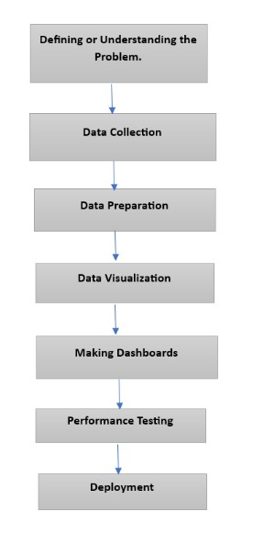

**Define Problem:**

**Specify the Business Problem:** India continues to experience alarmingly high rates of traffic accidents, leading to a significant number of fatalities and injuries annually, despite advancements in transportation that have made travel more efficient. The main issues include high accident rates, insufficient understanding of accident trends, lack of data-driven decisionmaking, and ineffective resource allocation. To enhance road safety, the goal is to identify accident hotspots, analyze patterns and causes, and develop a data-driven strategy to reduce fatalities and accidents, ultimately saving lives and improving road safety in India. The project aims to develop interactive dashboards for analyzing user demographics, accident patterns, and problem areas.

**Business Requirements:** To achieve the project goals, the following key requirements are identified:

**Data Integration:** Aggregate accurate data from various sources. **Dashboard Design:** Create user-friendly, interactive dashboards with filters and multiple views.

* + 1. **Data Visualization:** Utilize dynamic graphs, charts, and maps to present insights clearly.

Success will be measured by the clarity and utility of the insights provided by these dashboards.

**Literature Review:** Road traffic accidents result in a considerable number of fatalities and injuries each year, making road safety a major global concern. Improving road safety requires understanding the factors contributing to accidents and evaluating the effectiveness of various interventions.

**Road Safety Influencing Factors:**

**Human Behavior:** Distractions, speeding, and intoxicated driving are significant causes of accidents. Traffic law enforcement and education are crucial (Dingus et al., 2016).

**Vehicle Condition:** Poor vehicle maintenance, such as malfunctioning brakes and tire blowouts, increases accident risk (NHTSA, 2015).

**Road Infrastructure:** Quality of lighting, signage, and road design greatly impacts safety (Federal Highway Administration, 2018).

**Environmental Factors:** Adverse weather conditions like rain and fog elevate accident likelihood (Andrey et al., 2003).

**Efficacy of Interventions:**

**Legislative Actions:** Seat belt mandates and DUI laws reduce fatal accidents (Elvik, 2008).

**Engineering Solutions:** Roundabouts and pedestrian bridges enhance safety (Retting etal., 2003).

**Campaigns for Education:** Public awareness initiatives promote safe driving practices (Tison et al., 2010).

**Technological Innovations:** Advanced driving assistance systems (ADAS) help prevent accidents (Cicchino, 2017).

**Role of Analytics:**

* **Predictive Analytics:** Forecast high-risk behaviors and accident hotspots for preventive action (Abdel-Aty and Haleem, 2011).
* **Geospatial Analysis:** Use geographic information systems (GIS) to visualize accident data and identify trends (Anderson, 2009).
* **Big Data and Machine Learning:** Enhance precision in road safety data analysis (Montella et al., 2011).
* **Real-time Data Monitoring:** Telematics and IoT provide instant feedback on driver and vehicle performance (Barnaby and Boriboonsomsin, 2008).

In summary, a multimodal approach involving engineering solutions, education campaigns, legislative actions, and technological advancements is essential for improving road safety. Data analytics enable proactive measures to reduce accidents and improve safety. Future research should focus on leveraging advanced technologies and data-driven methods to continue enhancing road safety globally

# Identify the Performance Problem

## Performance problems

Despite technological advances in transportation, accidents remain a major issue in India, causing many deaths and injuries every year. A comprehensive data-driven approach is needed to understand accident patterns, identify high-risk areas, and implement effective safety measures Using Qlik Sense for this analysis will provide transferable insights have been used to improve road safety management, inform policy decisions, and ultimately save lives.

## business requirements

Interactive Dashboard: Visualize an attractive and interactive dashboard to visualize accident data.

Identify hotspots: Identify specific areas or roads where accidents are common.

Trend Analysis: Analyze historical data to identify accidents and recurring trends.

Predictive modeling: Use predictive analytics to predict potential accidents and issue early warnings.

Demographics: Provide insight into the demographics of accident victims, including age and gender distributions.

Accidents severity: Compare accident severity and traffic conditions at different locations.

Neural Analysis: Identify major causes of accidents, such as speeding or distracted driving.

Neural Analysis: Identify major causes of accidents, such as speeding or distracted driving.

Vehicle Contribution: Find the contribution of vehicles to the total number of accidents.

Annual and seasonal analysis: Find date and time series of accidental seasonal changes.

# Book Review

Conducting a literature review involves researching previous studies and reports on road safety and accident investigation. Things to consider include:

Academic databases: PubMed, IEEE Xplore, Google Scholar for peer-reviewed articles and research papers.

Government Reports: Publications and statistics from government agencies on road safety.

Institutional archives: reports and studies from travel research institutes and universities.

Previous studies: Methods, procedures used in previous studies, and data from those studies.

# social or business impact

## Social influence

Population diagram: Show the distribution of accidents in the population to understand which groups are most affected.

Accident Severity Rating: Highlight severe accident areas to prioritize safety measures.

Correlation Analysis: Examine the relationship between speed, weather, and accident rates.

Cause identification: Identify key causes of accidents to identify targeted interventions.

Victim population: Examine the age and gender distribution of accident victims in relation to awareness training programs.

The contribution of vehicles: To understand the impact of vehicles on road safety to inform laws and policies.

# A collection of information

## Collect the Dataset

For detailed analysis, the following data should be collected.

Traffic data: Information about the number, speed, and flow of traffic.

Accident Report: A detailed report of a road accident, including location, time and severity.

Weather: Historical and real-time weather data affecting road conditions.

Detailed travel information: Information on different modes, conditions and services.

Demographic Information: Information on age, sex, and other accident demographics.

## Connect Data with Qlik Sense

Data Integration: Import collected data into Qlik Sense.

Data cleaning: Clean and preprocess data to ensure integrity and accuracy.

Data modelling: Create a data model in Qlik Sense to link data types (e.g., link accident reports to traffic data and weather).

Visualization: Create interactive dashboards and visualizations for data analysis and interpretation.

Analytics: Use Qlik Sense’s analytics capabilities to identify hot spots, find trends, and create predictive models.

Reporting: Develop reports and insights to be shared with stakeholders for informed decision making.

# Data Visualizations

## Number of Unique Visualizations

The number of unique visualizations that can be created with a given dataset. Some common types of visualizations that can be used to analyse include bar charts, line charts, heat maps, scatter plots, pie charts, maps etc. These visualizations can be used to compare, track changes over time, show distribution, relationships between variables, breakdown of one category and much more.

Activity 1.1: Accidents Due to Drunken Driving

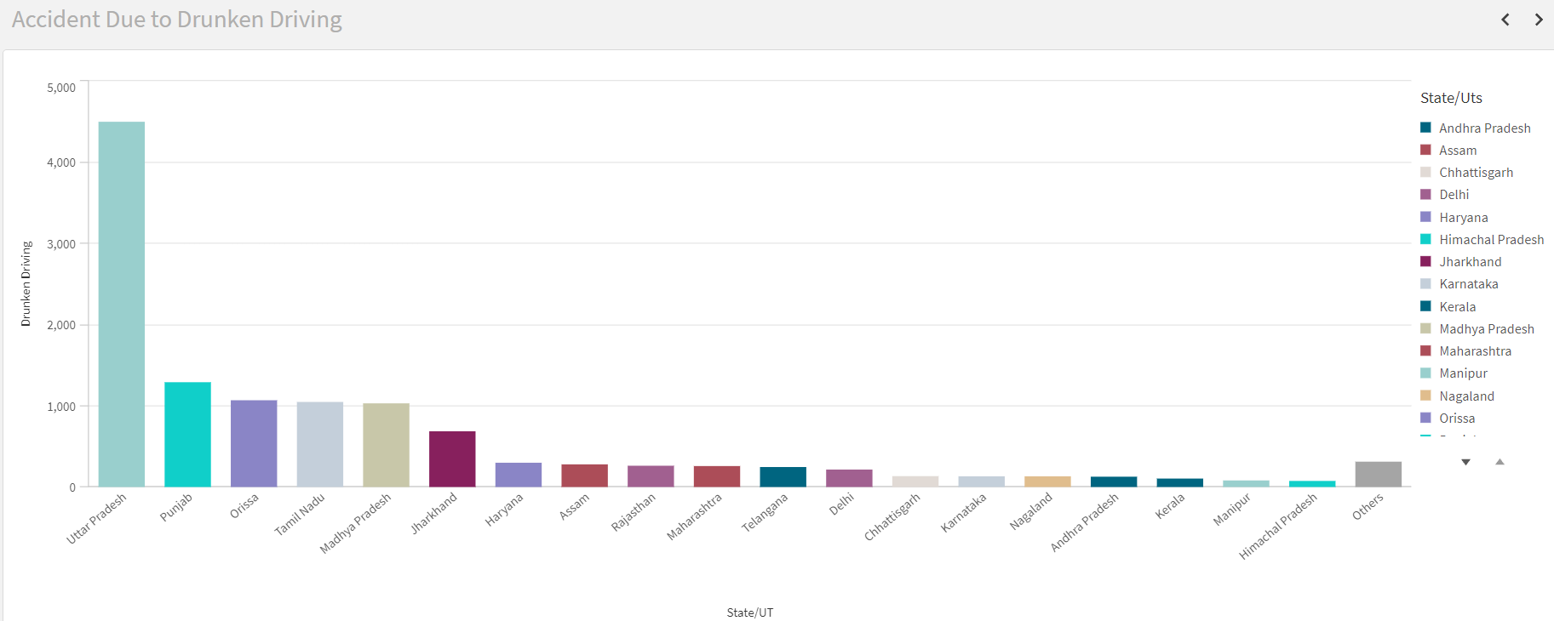

Activity 1.2: State-wise Mobile Phone Usage

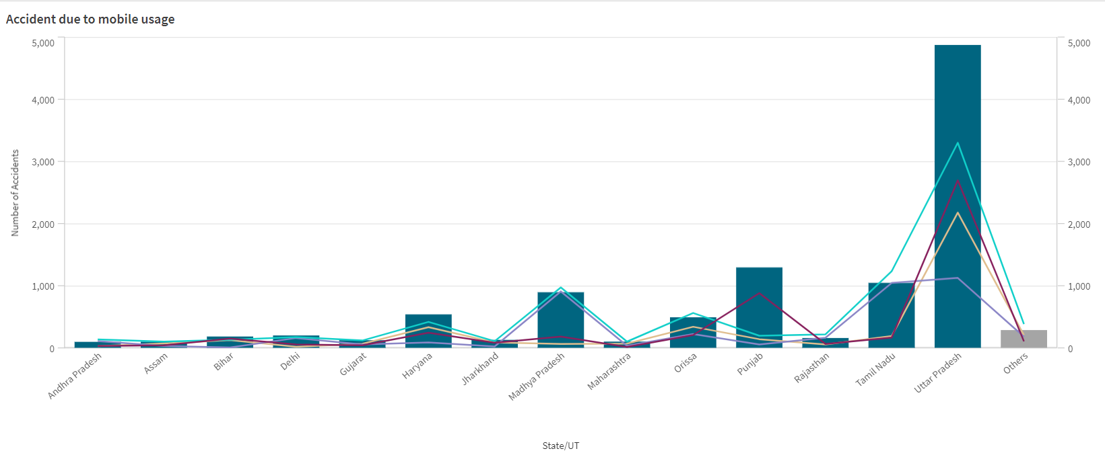

Activity 1.3: Pedestrians Killed: Age groups

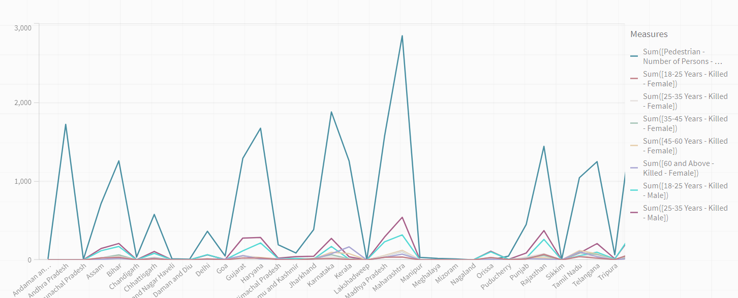

Activity 1.4: Vehicle Contribution towards Total Accidents

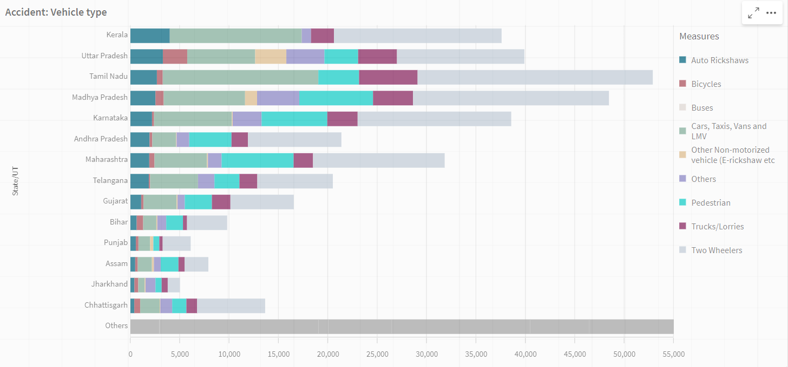

Activity 1.5: Accidents by Weather Type

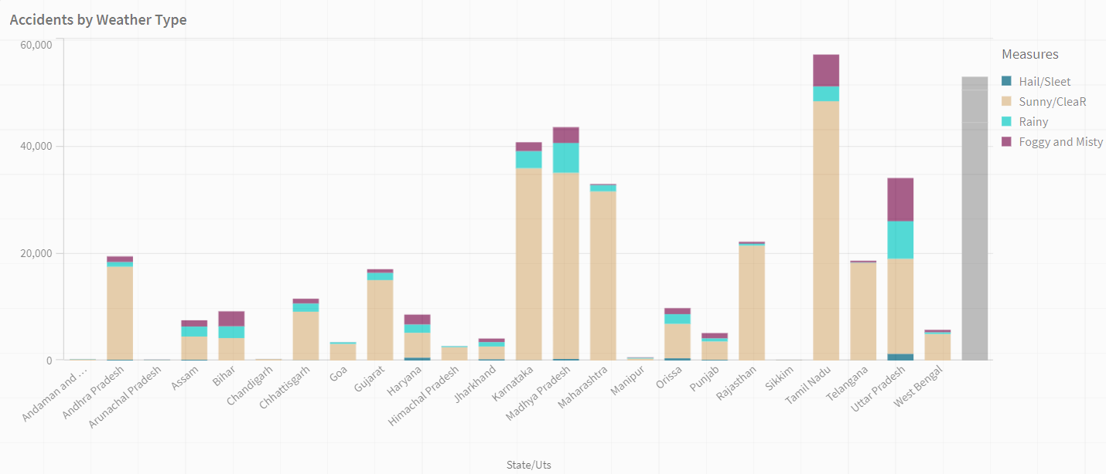

Activity 1.6: Pedestrians Killed: Gender

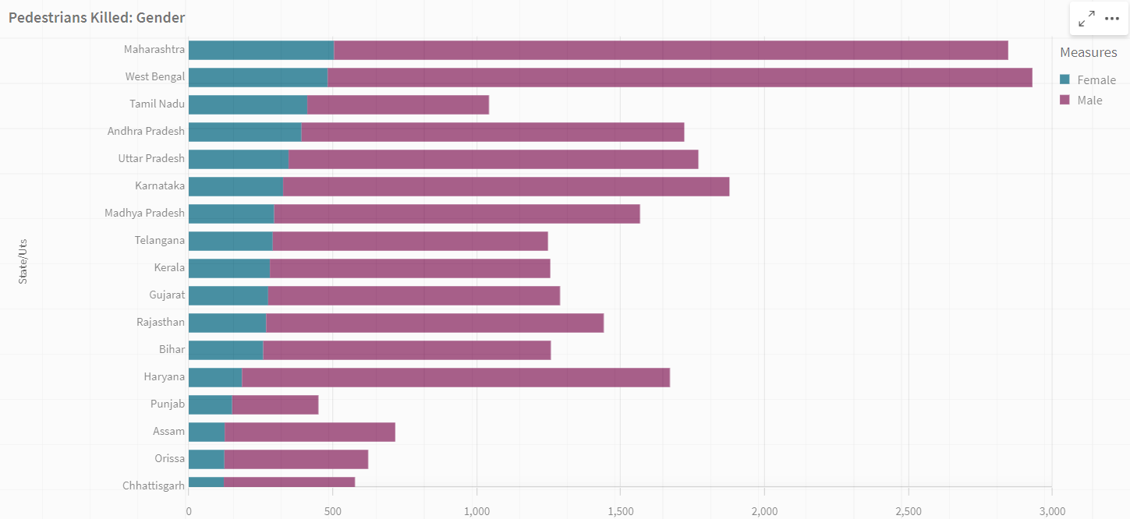

Activity 1.7: Road Users Killed: Vehicle Distribution

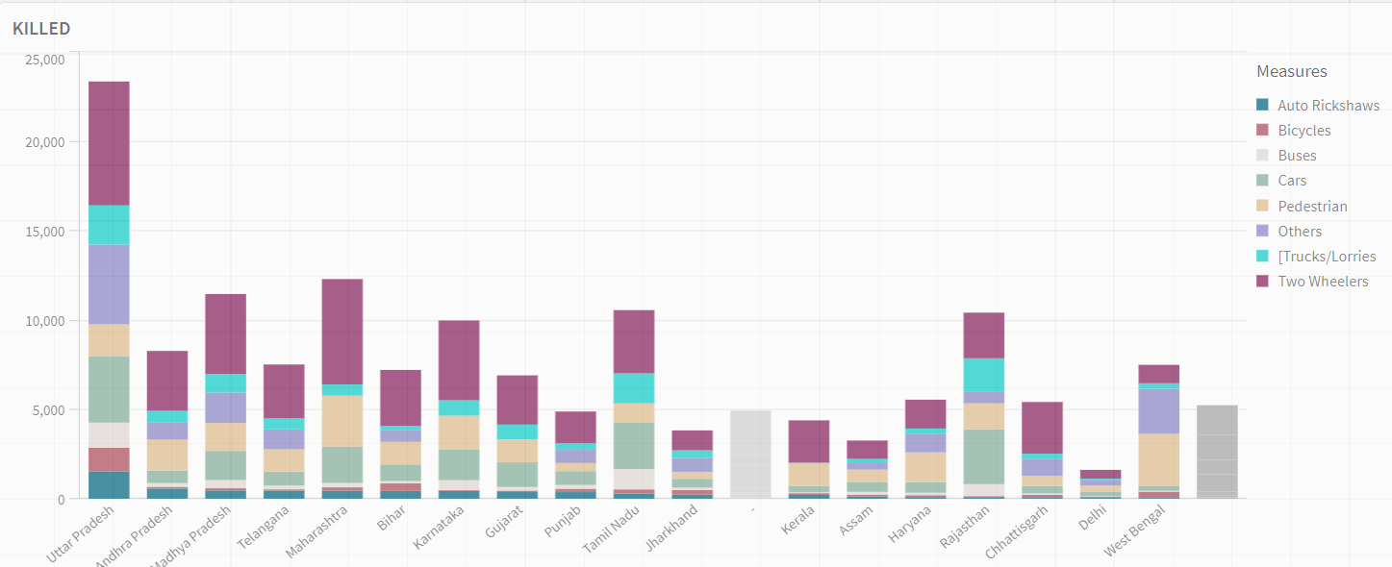

Activity 1.8: Correlation - Speeding and Number of accidents

Activity 1.9: Minors Injured across the country

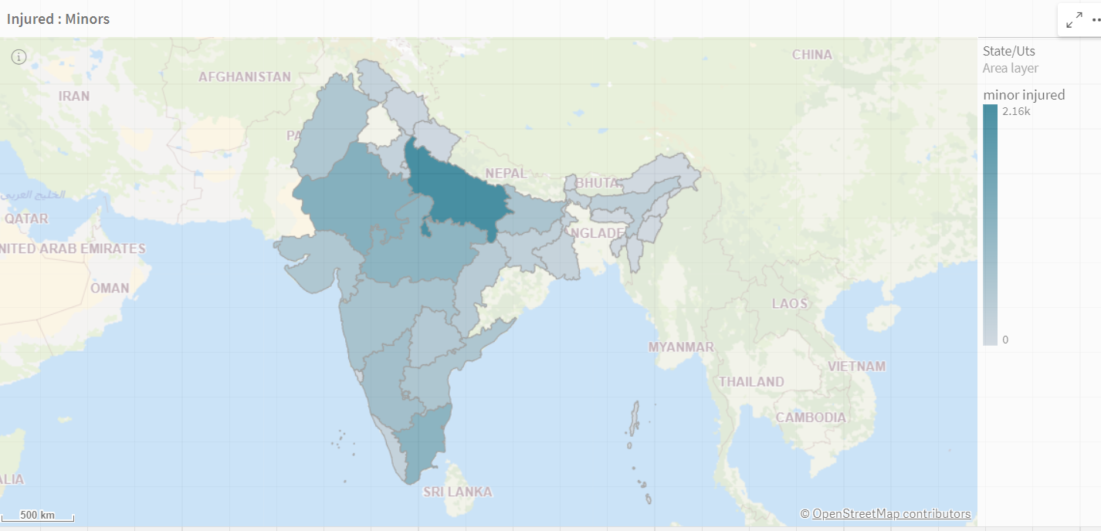

5. Responsive and Design of Dashboard

Dashboard: Accidents near Traffic Signals 

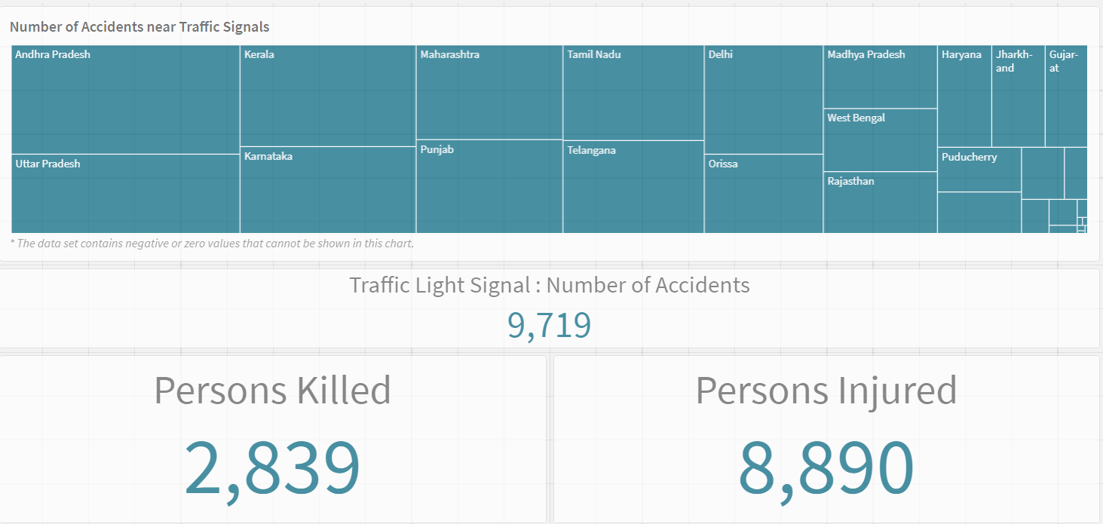

Dashboard: Accidents in Police Controlled Areas

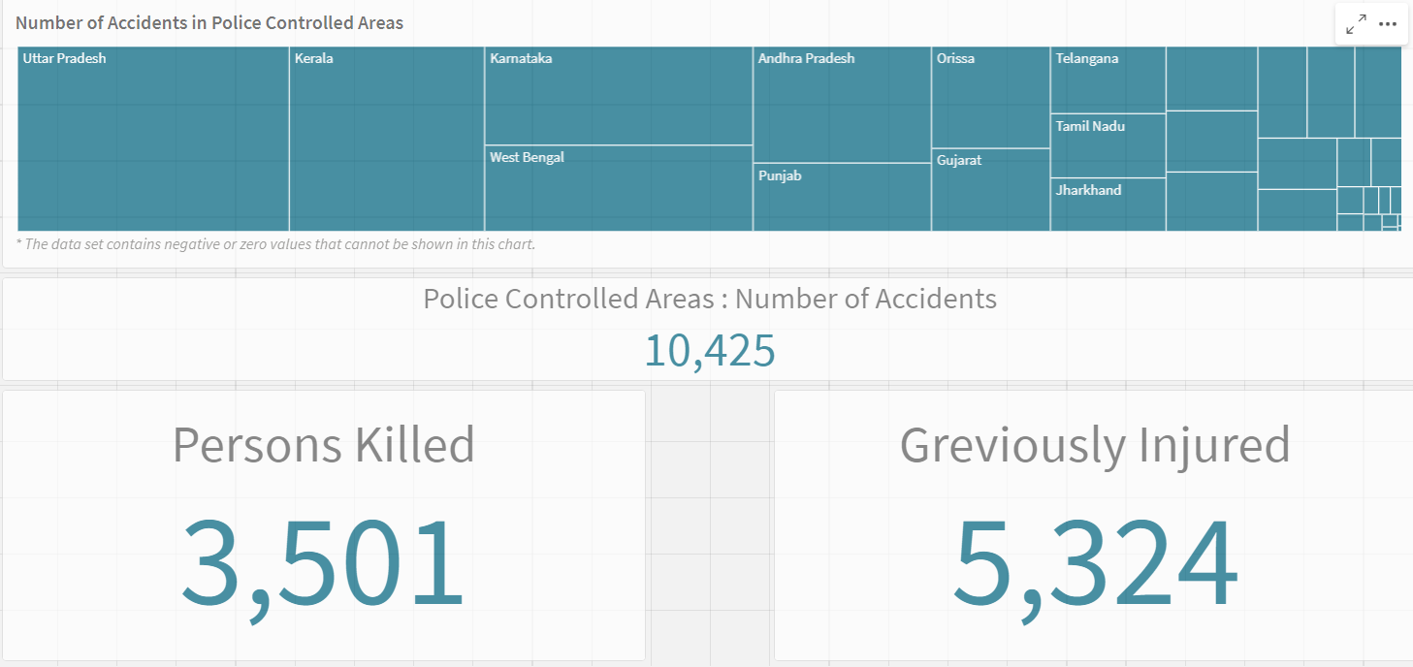

# Story Creation

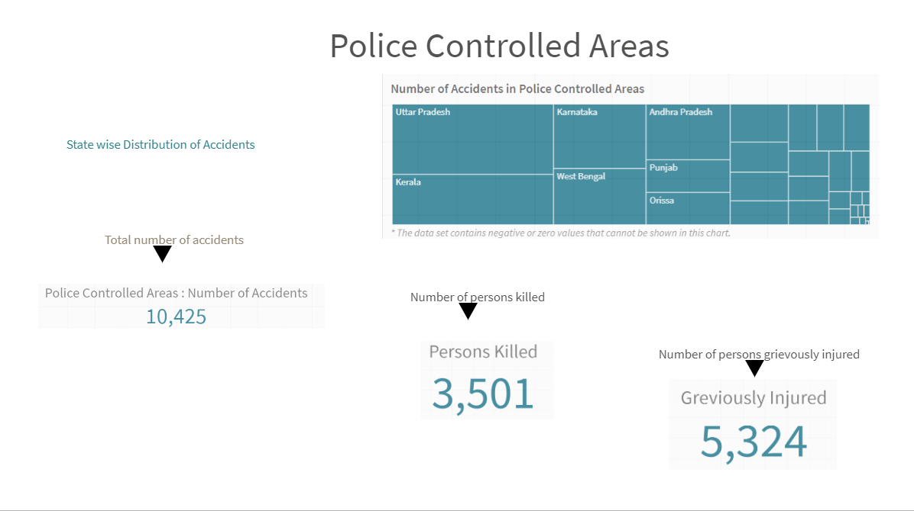

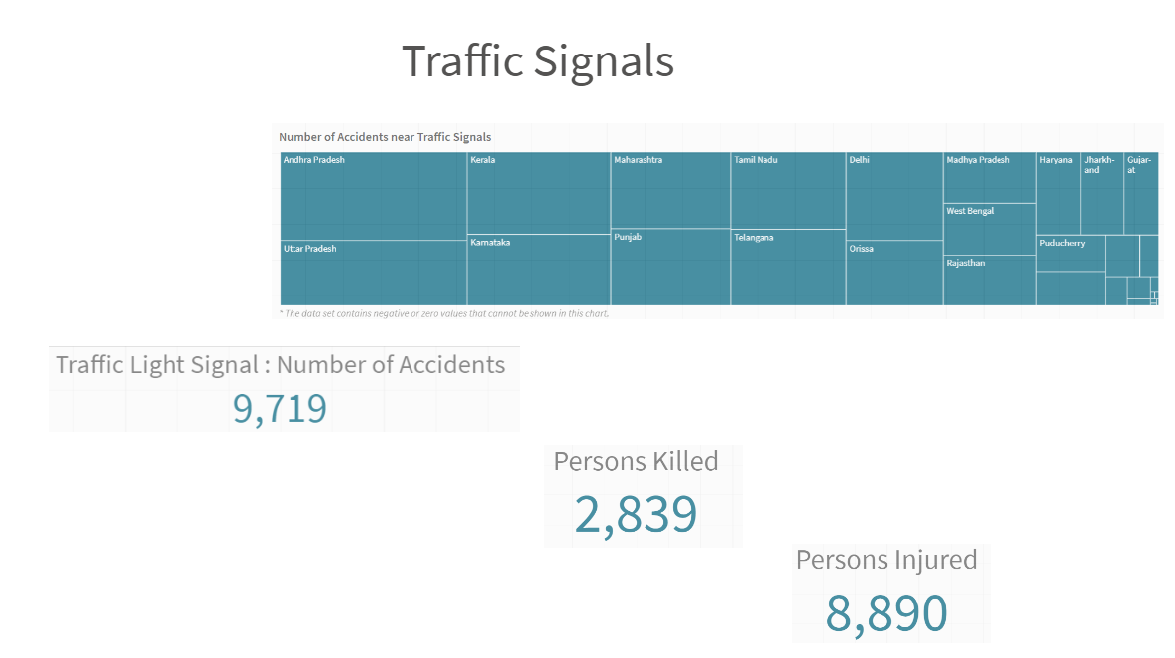

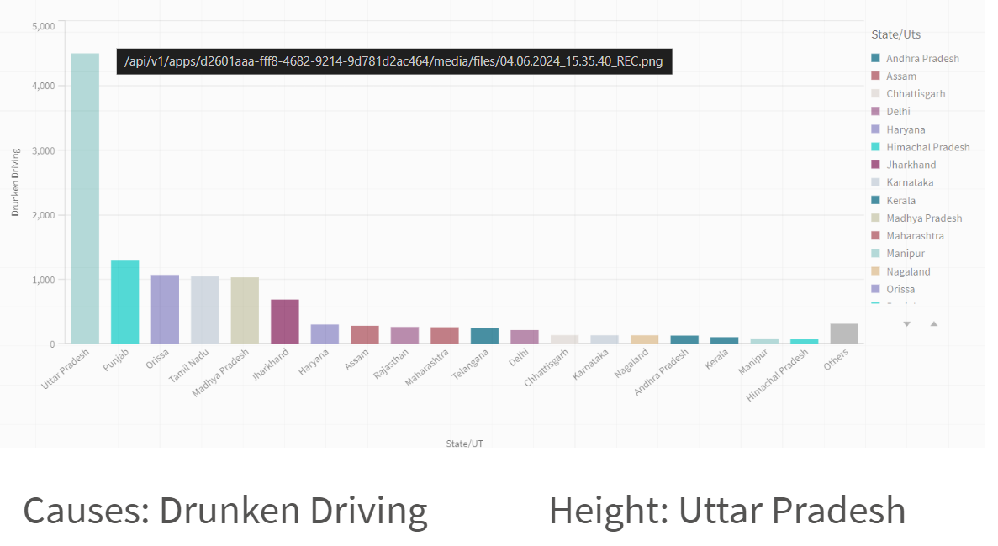

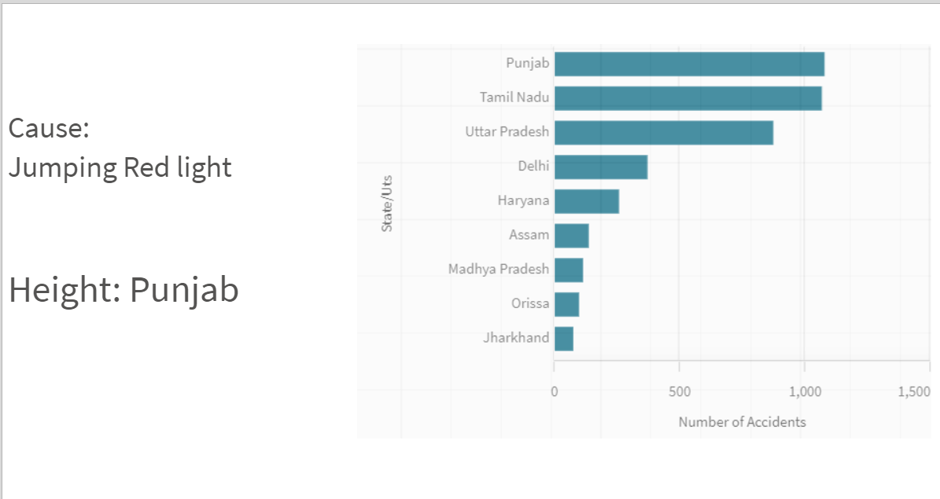

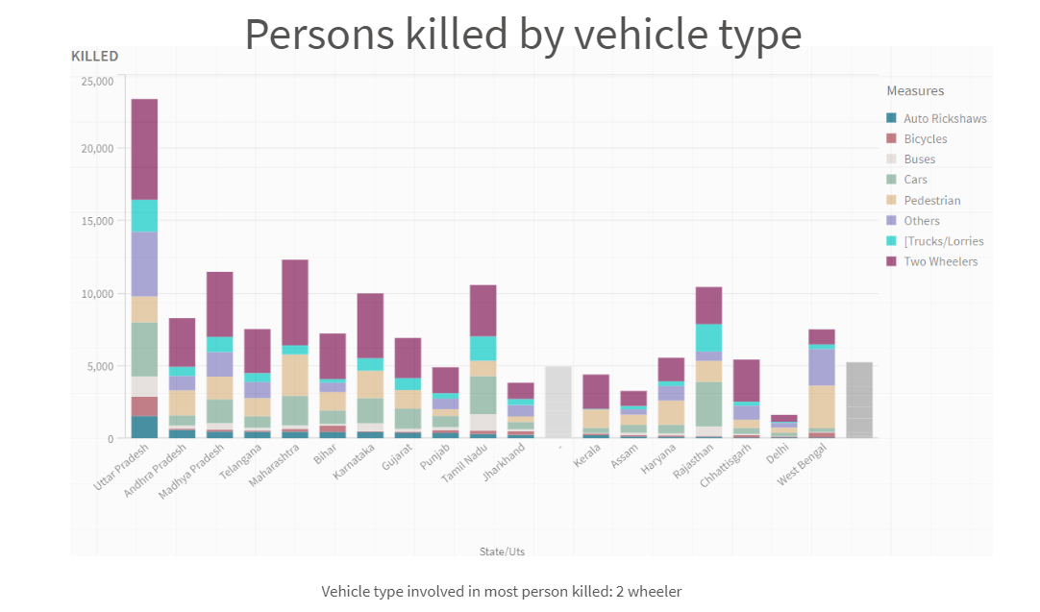

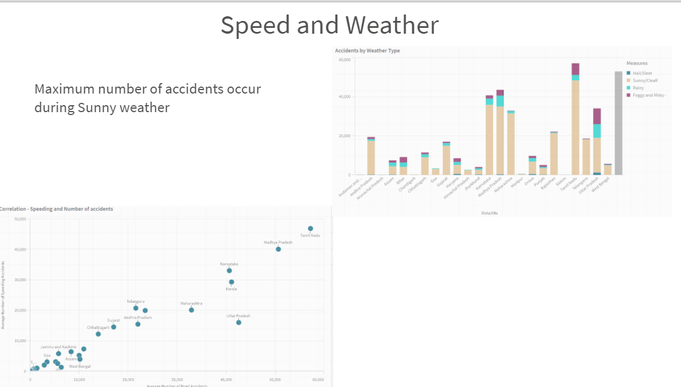

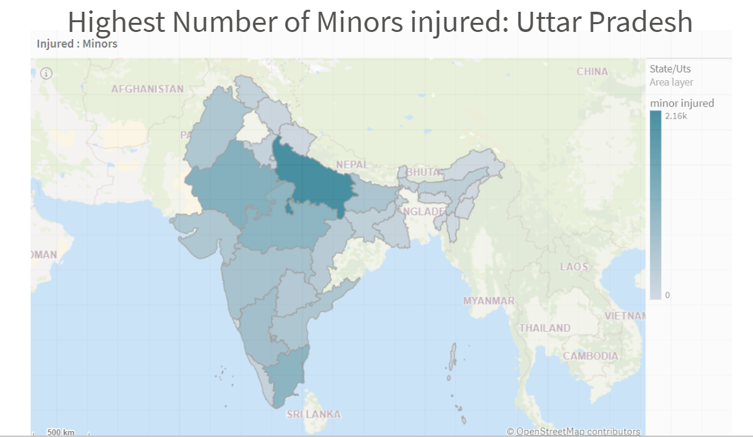

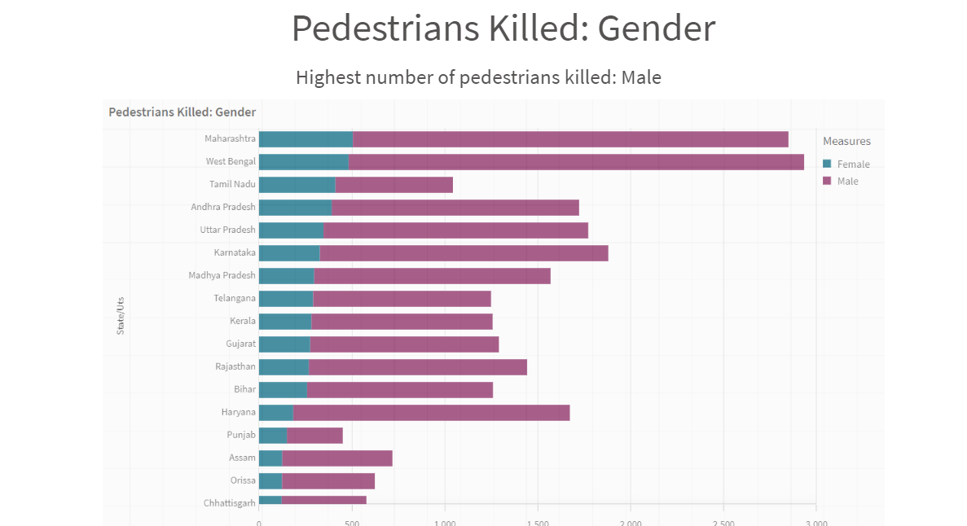

# Performance Testing

### Utilization of Data Filters

Selections within the data allows users to filter data based on individual fields or dimensions. Users can choose specific values within a field to include or exclude from analysis.Complex filters based on predefined conditions and logic can also be created.

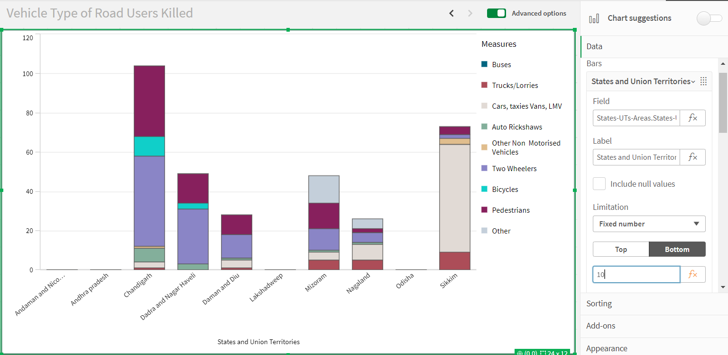

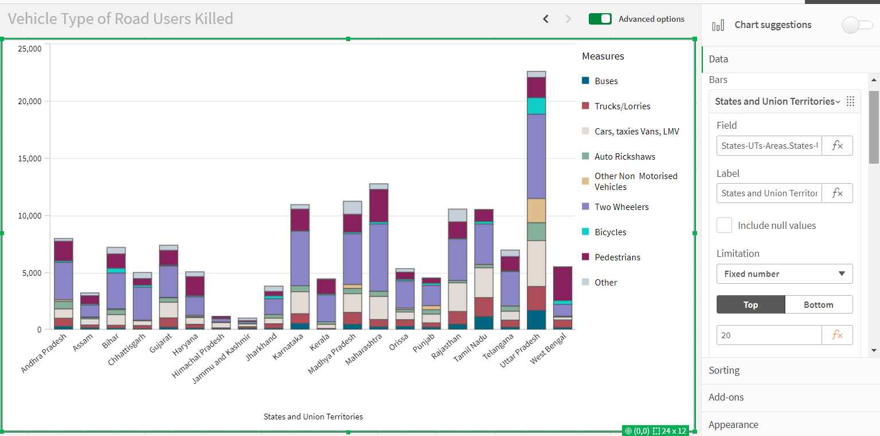

### Number of Calculation Fields/Master Items

Qlik Sense allows the creation of reusable filter objects like Master Items, Calculated Fields which can simplify the process of applying consistent filters across multiple visualizations and dashboards.

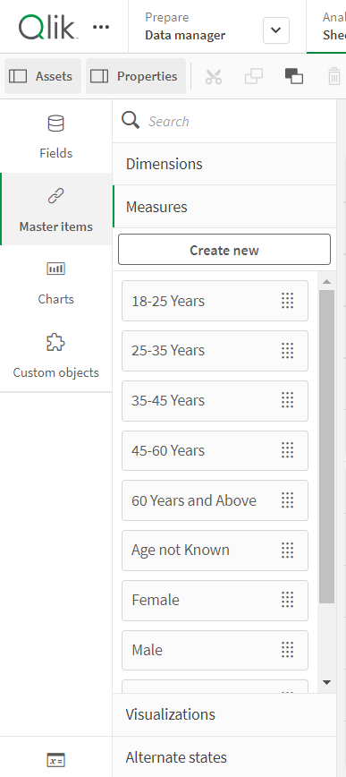

### Number of Visualizations/Graphs

1. Accidents due to Drunken Driving
2. State-wise Mobile Phone Usage
3. Vehicle Contribution towards Total Accidents
4. Correlation - Speeding and Number of accidents
5. Accidents by Weather Type
6. Minors Injured across the country
7. Pedestrians Killed: Gender
8. Pedestrians Killed: Age groups
9. Road Users Killed: Vehicle Distribution

## Use of Filters

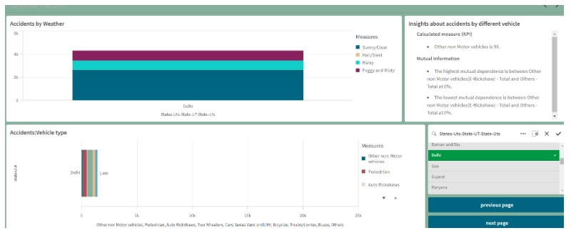

# Conclusion

This report provides a detailed analysis of road safety and accident patterns in India, uncovering key factors influencing accidents and casualties. It offers actionable insights that can be utilized to enhance safety measures and strategies for reducing accidents and improving overall road safety.

GitHub Link: <https://github.com/Arvindoffical/Road-Safety-and-Accident-Patterns-in-India.git>

Qlik Link: <https://w5mow4uamnv5ays.us.qlikcloud.com/sense/app/d2601aaa-fff8-4682-9214-9d781d2ac464>

Video Demonstration: <https://drive.google.com/file/d/1bcx15YbhjaveNbjmWt5K3q3ONBIYxY0Y/view?usp=sharing>